EXPERIMENT 08
Simple Single Page Web Application using React JS
Saanvi kulkarni
B2
16010125118
Course Outcome: CO5 – Illustrate the concepts of various front-end web application developments, mockApi technologies frameworks using different web development tools.

Aim: To develop a simple Single Page Web Application using React JS using reusable components, JavaScript data, JSX and React Router.

Objectives
- Understand the concept of a Single Page Application (SPA).
- Create multiple React components representing application views.
- Implement client-side navigation using React Router.
- Use JavaScript arrays and map() to generate UI elements.
- Reuse JSX, components and state concepts learned in Experiment 07.
NOTE: Refer to the “Case Study you selected” and complete the tasks in React. This write-up uses Student Information Application as a sample.

Software Requirements
- Node.js and npm
- Visual Studio Code
- Google Chrome or another modern browser

Theory

Single Page Application (SPA)
An SPA loads an application shell and changes the displayed view on the client without requiring a complete browser document reload for every internal route. React can implement this model using a routing library.

React Router
React Router provides BrowserRouter, Routes, Route and Link for mapping URL paths to React components and navigating between views.

Link and HTML Navigation
- HTML commonly uses <a href="/about">About</a>.
- React Router uses <Link to="/about">About</Link> for client-side navigation.
- The goal is to switch application views without a full page navigation.

JavaScript map() in React
students.map(student => (
<p key={student.id}>{student.name} - {student.course}</p>
));

Problem Statement
Develop a simple Student Portal SPA containing Home, Students and About views. Navigation must use React Router. The Students view must generate records from a JavaScript array using map().

Tasks to be Given to Students
- Create a React application named student-portal.
- Install react-router-dom.
- Create Home.js, Students.js and About.js components.
- Create navigation links for Home, Students and About.
- Configure BrowserRouter, Routes and Route.
- Display a welcome message on Home.
- Display at least three student records using an array and map().
- Use a unique key for each generated item.
- Display application information on About.
- Apply simple CSS.
- Test all routes and capture screenshots.

Procedure
- Open Command Prompt and navigate to the practical folder.
- Run: npx create-react-app student-portal
- Run: cd student-portal
- Run: npm install react-router-dom
- Run: npm start
- Create a pages folder inside src.
- Create Home.js, Students.js and About.js.
- Write the components.
- Import them into App.js.
- Configure BrowserRouter, Routes, Route and Link.
- Test /, /students and /about.

Program – Home.js
function Home() {
return (
<div>
<h1>Welcome to Student Portal</h1>
<p>This is the home page.</p>
</div>
);
}
export default Home;

Program – Students.js
function Students() {
const students = [
{ id: 1, name: "Riya", course: "B.Tech" },
{ id: 2, name: "Amit", course: "BCA" },
{ id: 3, name: "Neha", course: "B.Tech" }
];
return (
<div>
<h1>Student List</h1>
{students.map(student => (
<p key={student.id}>
{student.name} - {student.course}
</p>
))}
</div>
);
}
export default Students;

Program – About.js
function About() {
return (
<div>
<h1>About</h1>
<p>Student Portal is developed using React JS.</p>
</div>
);
}
export default About;

Program – App.js
import { BrowserRouter, Routes, Route, Link } from "react-router-dom";
import Home from "./pages/Home";
import Students from "./pages/Students";
import About from "./pages/About";
function App() {
return (
<BrowserRouter>
<nav>
<Link to="/">Home</Link> |{" "}
<Link to="/students">Students</Link> |{" "}
<Link to="/about">About</Link>
</nav>
<Routes>
<Route path="/" element={<Home />} />
<Route path="/students" element={<Students />} />
<Route path="/about" element={<About />} />
</Routes>
</BrowserRouter>
);
}
export default App;

Expected Output
The application provides Home, Students and About navigation. Selecting a navigation link displays the corresponding React component without creating separate HTML pages.
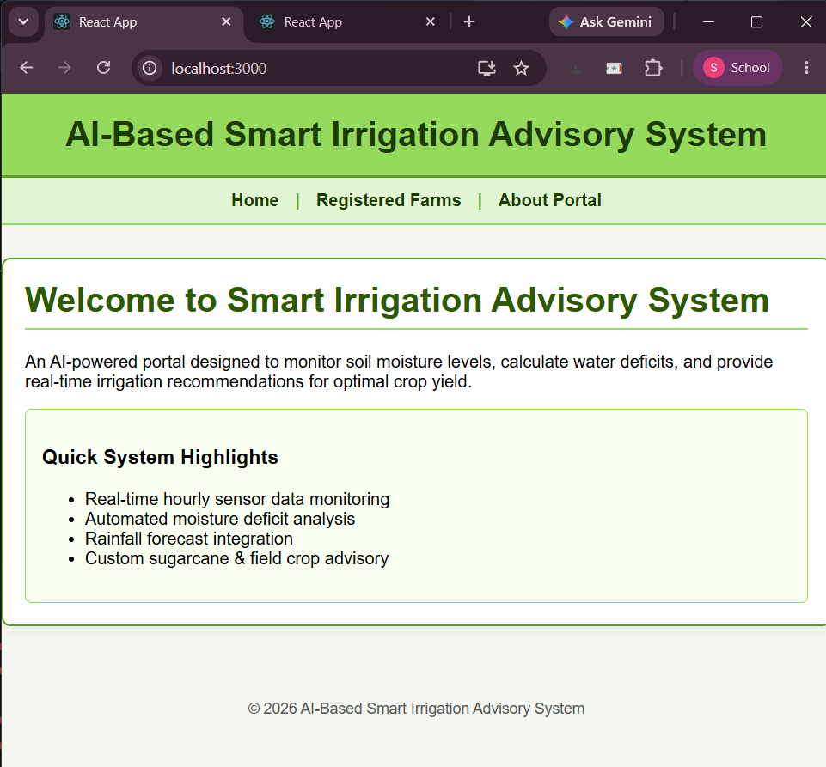
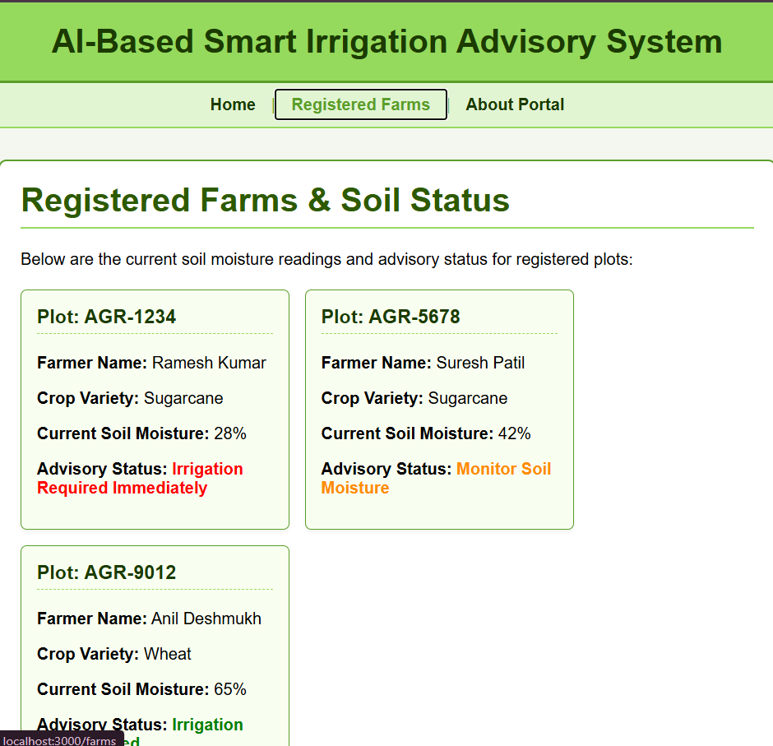
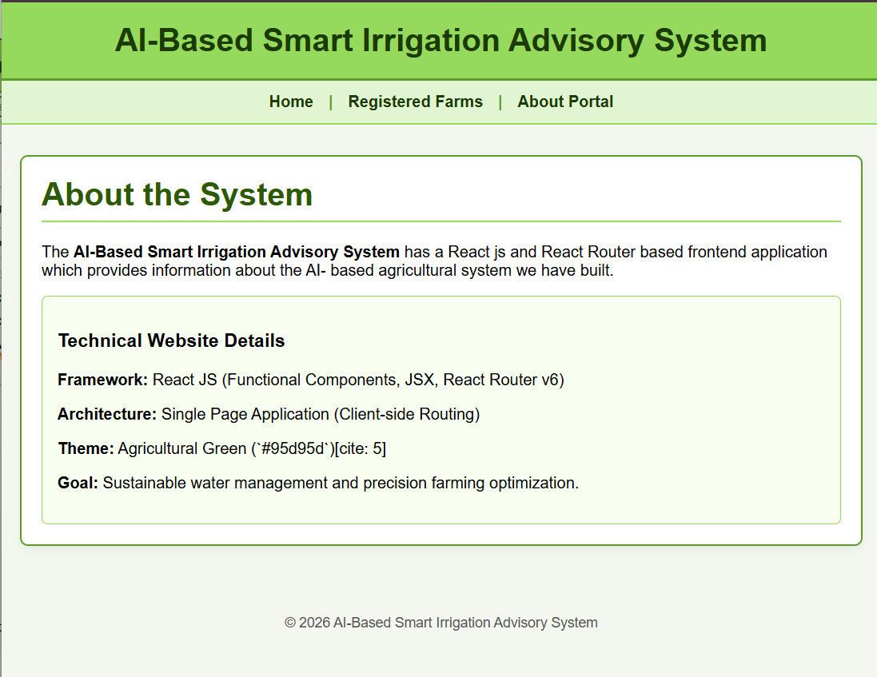

Result
A simple Single Page Web Application was developed successfully using React JS, reusable components and React Router.

Viva Questions
- Why is React Router used?
Ans: React Router is used to build Single Page Applications (SPAs) by handling client-side routing. It enables switching views by changing the browser URL without requiring a full page reload from the server.

- What are BrowserRouter, Routes and Route?
Ans:
• BrowserRouter: The top-level parent component that wraps the app and synchronizes the UI with the browser's URL history.
• Routes: A container component that evaluates all nested <Route> definitions and renders the best matching route.
• Route: Defines the mapping between a specific URL path (path="/") and the React component to render (element={<Home/>}).

- What is the difference between Link and an HTML anchor?
Ans: • An <a> tag (<a href="...">) triggers a full browser refresh and fetches a new document from the server.
• A <Link> component (<Link to="...">) intercepts the click, updates the URL history locally, and renders the target React component instantly without reloading the page.

- Why is key used in React lists?
Ans: The key prop gives elements inside an array a unique identity. It helps React's Virtual DOM diffing algorithm identify which items have changed, been added, or removed, optimizing performance during list re-renders

- How does map() help in React?
Ans: .map() iterates over a JavaScript data array and transforms each element into a JSX component or block, allowing dynamic list rendering from raw data

- How does Experiment 08 extend Experiment 07?
Ans: Experiment 07 focused on building individual, isolated functional components with props, state, and events. Experiment 08 extends this by connecting multiple components into a full Single Page Application (SPA) using client-side routing with react-router-dom and rendering lists dynamically via .map()

